# IT 230 Coding Activity Submission Template

Submit your work on the coding activities for Modules One, Two, Three, Four, and Six in this document. In addition to this document, you should submit a ZIP file containing all your Visual Studio project files and source code that can be run in Visual Studio on a different computer.

For each coding activity, complete the following steps:

* Download and rename this document to meet the file naming conventions requested in the assignment instructions.
* Fill in the required information below by replacing the bracketed text with the relevant information.
* Submit this document and your ZIP file for grading and feedback. Your ZIP file should follow the same naming conventions.

Document your work in the coding activity by completing each of the following items:

1. Provide a screenshot of the output that resulted from running your program successfully in Visual Studio. See the coding assignment instructions for an example of what should be included in the screenshot. Your screenshot must include the following elements:
   1. Your last name as the first printed text on the screen
   2. Verification that the program is fully functioning and data results are accurate for the given problem

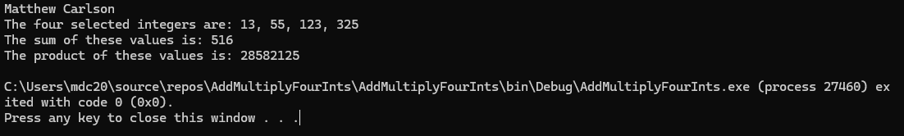

1. Copy and paste the source code text you wrote for this assignment from the *.cs file into the space below. Only providing the *.cs files or a screenshot does not meet the requirements for this part of the assignment. Code should be logically organized. It should also follow proper syntax and conventions noted in the Coding Activity Guidelines and Rubric.

using System;   
using System.Collections.Generic;   
using System.Linq;   
using System.Text;   
using System.Threading.Tasks;

namespace AddMultiplyFourInts   
{  
 class Program   
 {  
 static void Main(string[] args)  
 {   
 int val1 = 13; // Declare ints   
 int val2 = 55;   
 int val3 = 123;   
 int val4 = 325;  
 int valSum = val1 + val2 + val3 + val4; // Sum ints  
 int valProduct = val1 * val2 * val3 * val4; // Multiply ints

Console.WriteLine("Matthew Carlson");  
 Console.WriteLine("The four selected integers are: " + val1 + ", " + val2 + ", " + val3 + ", " + val4);  
  
 Console.WriteLine("The sum of these values is: " + valSum);  
 Console.WriteLine("The product of these values is: " + valProduct);

}  
}

}

1. Show that you understand the task by explaining the design of your program in the space below. Include the process and steps you took to write your code. Explain how you arrived at the solution to the problem and completed the activity.

This coding solution is made simpler based on the fact that we have set values to utilize. The first step in writing this program is utilizing the textbook’s information on declaring variables to, indeed, declare all four of the variables, being 13, 55, 123. 325. The second step is to declare another int variable equal to the sum of these four variables. Then, one more equal to the product. These two operations are done using basic operators covered in chapter 2 of our textbook.

Then, just as we’d done in our discussion, it was a simple matter of printing a few statements utilizing WriteLine() with the integer variables concatenated onto the string.

1. Reflect on your learning experience and what you learned from completing the activity.

Through this experience I learned that, once again, C# string writing is almost the exact same as Java. It's a pleasant surprise to see that using the same tricks I’d learned, with particular regard to connecting variables with spaces and commas, I can make the program output what I desire it to.